11/9/2011-dw

OSBM RVP DATABASE Seasonal Position Request
For dates: 1/1/2012-6/30/2012
Database link: www.dpr.ncparks.gov/databases.php
Database Instructions/Procedures/Tips for parks to request seasonal positions for budget funding consideration to the District level.
PARK DEADLINE for database procedure &email and to the DISU: 11/30/2011

Once the District has reviewed all parks for seasonal funding consideration based on the projected District budget information from CHOP. Email is forwarded to OPS for Division Level funding consideration and OSBM RVP preparation. By close of business day 12/5/2011.
DISTRICT DEADLINE for DIST review/approval & email to the CHOP: 12/05/2011
****All requests are subject to OSBM RVP process and have not been approved for hire.

Instructions posted to FIND Database # 261 ... details ±
Seasonal Position DATABASE OSBM RVP REQUEST INSTRUCTIONS FOR
1/1/2012-6/30/2012.

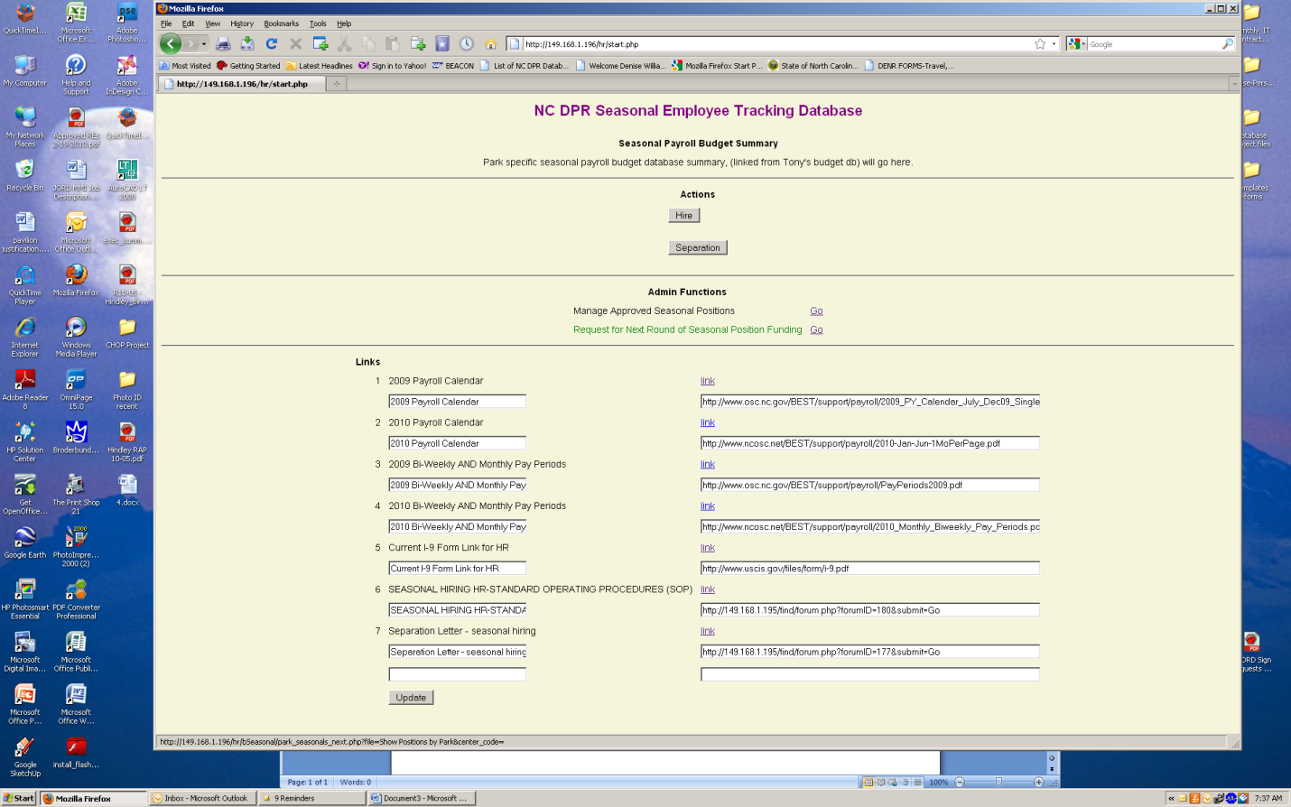
Step 1
Enter Request for Next Round of Seasonal Position Funding Go

Step 2 - What positions do you need during 01/1/2012-6/30/2011?
☑ Check the box beside each projected OSBM Position Title the park would like to hire individually.
#positions assigned to PARK includes columns:
Comments (previous RVP approval# RVP 10… in the comments field-these positions are currently approved for hire during 7/1/2011-12/31/2011
Employed (currently employed last name and SS#)
Separated (last separated employee last name and SS#)
THEN
Submit

Step3 - The projected position(s) have now moved to the top block of the next screen so that you may begin the budget process. # of positions assigned to park are in the bottom block and are for reference only.
☑ check the box beside center
Enter the projected hire date for this position – any date of hire between 01/1/2012-6/30/2012
(This must be done to continue position from previous RVP 10 approved cycle or it has an employee working thru the last day of that approved cycle 12/31/2011)
Enter weekly budgeted hours (example: 40 -5 days at 8hrs per day or 16 for weekend 2 days at 8hrs, etc.
Enter the number of 7-day weeks to work this position (example: thru Labor Day would be 10 full weeks)
Enter park comments in this block comments may include additional justification for this position request to the DISU or park specific instructions by the hiring mgr, SUPT, etc.
UPDATE

You will now see a total budget for the dollars for the requested position(s)
*To view payments to park employees during this FY enter the link Budget database Payroll *To view your park budgeted or current seasonal temporary payroll balance proceed to the Budget Database.

Important
Step 4- Email
Park Use this email link when you have completed all requested positions for the park. You may add additional comments in the body of the email. Then send to the District Superintendent & District OA for the next part of the RVP approval process.
If the park has questions about any of these steps contact your District OA.

District Level-Instructions
Enter the link in the email from the park.
Compare all of the parks requested positions and totals to the projected budget total for your district from the CHOP.
Contact the parks if adjustments should be made or if you have questions.
Once the district has a final projected budget total for the OSBM RVP request procedure:
e-mail the CHOP & OPS Admin. Assistant- Denise
If you have questions about any of these steps contact Denise at 919-715-7616 or email denise.williams@ncdenr.gov

